1) How to Create Hyperlinks in HTML?
Answer:
In HTML, hyperlinks are created using the `<a>` (anchor) tag. The `href` attribute specifies the destination URL. Here’s a basic example:
<a href="https://www.example.com">Visit Example</a>
This link, when clicked, will take the user to "https://www.example.com".
2) Write Attributes of Anchor Tag
Answer:
The `<a>` tag has several common attributes:
- `href`: Specifies the URL of the page the link goes to.
- `target`: Specifies where to open the linked document. Common values are `_self` (default, opens in the same tab) and `_blank` (opens in a new tab).
- `title`: Provides additional information about the link as a tooltip.
- `download`: Allows the user to download the linked file rather than navigating to it.
- `rel`: Specifies the relationship between the current document and the linked document (e.g., `nofollow`, `noopener`).
3) implement the below application with anchor tag
Flipkart -> https://www.flipkart.com/
Amazon -> https://www.amazon.in/
AJIO -> https://www.ajio.com/
Myntra -> https://www.myntra.com/
Load above web sites in new tab
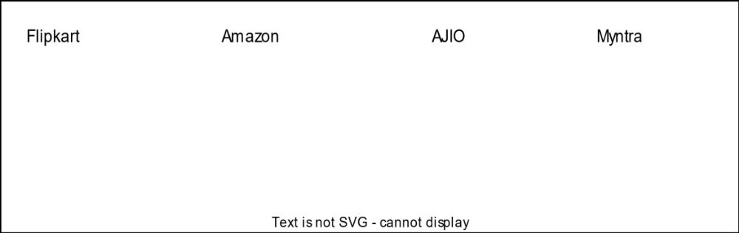
Code :
<!DOCTYPE html>
<html lang="en">
<head>
<meta charset="UTF-8">
<meta name="viewport" content="width=device-width, initial-scale=1.0">
<title>Anchor tag </title>
</head>
<body>
<div style="display: flex; gap:20rem;font-size: 2rem;">
<a href="https://www.flipkart.com/">Flipkart </a>
<a href="https://www.amazon.in/">Amazon</a>
<a href="https://www.ajio.com/">ajio</a>
<a href="https://www.myntra.com/">myntra</a>
</div>
</body>
</html>
Output :
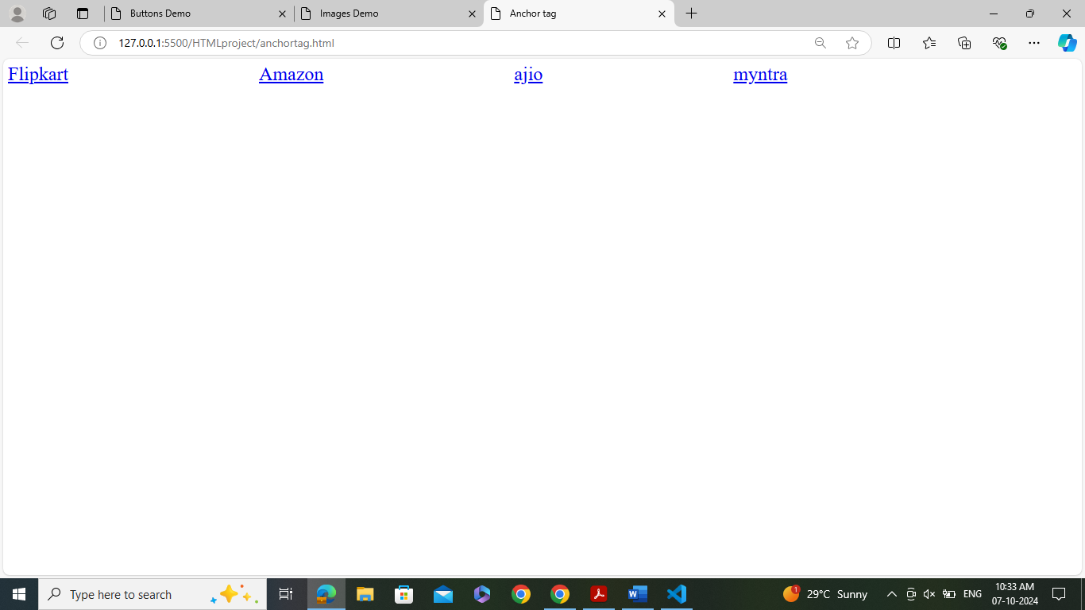
4) implement the below application with anchor tag
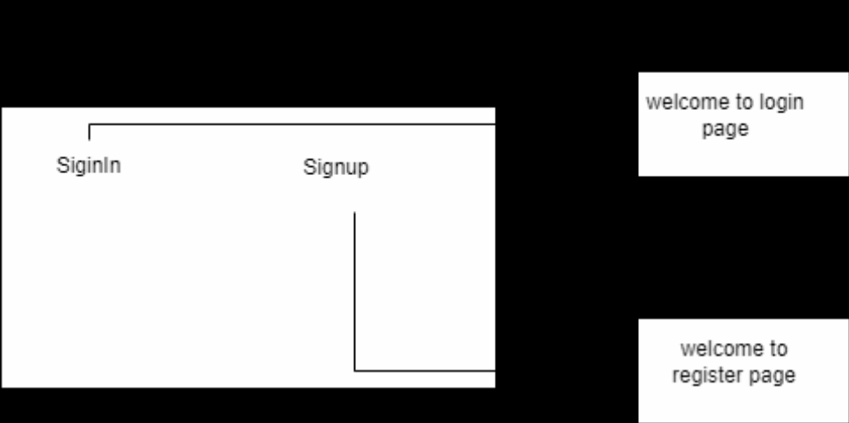

Home .html
<!DOCTYPE html>
<html lang="en">
<head>
<meta charset="UTF-8">
<meta name="viewport" content="width=device-width, initial-scale=1.0">
<title>Home Page</title>
</head>
<body>
<div style="display: flex; gap: 20rem; font-size: 2rem;">
<a href="login.html">Signin</a>
<a href="register.html">Signup</a>
</div>
</body>
</html>
Login.html
<!DOCTYPE html>
<html lang="en">
<head>
<meta charset="UTF-8">
<meta name="viewport" content="width=device-width, initial-scale=1.0">
<title>Document</title>
</head>
<body>
<h1 style="color: red;"> welcome to Login Page</h1>
<br>
<a href="home.html">Back to home</a>
</body>
</html>
Register.html
<!DOCTYPE html>
<html lang="en">
<head>
<meta charset="UTF-8">
<meta name="viewport" content="width=device-width, initial-scale=1.0">
<title>Register Page</title>
</head>
<body>
<h1 style="color: red;"> welcome to Register Page</h1>
<br>

<a href="home.html">Back to home</a>
</body>
</html>
Outputs:
